Git Set up steps:-

1. Download Git-2.42.0.2-64-bit application from https://git-scm.com/downloads and install it
2. Create a folder in your PC and inside this folder right click and Select ‘ Git Bash here’
3. Execute following commands

* git init
* git clone https://github.com/Archana-B11/workwithcpp

Git bash is application for command line experience.

We can work with git in two ways : through commands and GUI

Git Commands:-

* git init - for first step and only once executable to initialize
* git clone <https://github.com/Archana-B11/workwithcpp> - is used to copy the already existing repo into your local pc
* ls – is used for listing all files and folders
* git branch -all – is used to see all branch in that repo

Task 1:

Adding new file and commit and make changes in existing file and comit

* first go to specified path mentioned in the task 1 file and create a file as you wish with some content.
* go to Git bash –(to get git bash terminal, go to git folder and right click)
* Execute below commands

1. git status
2. 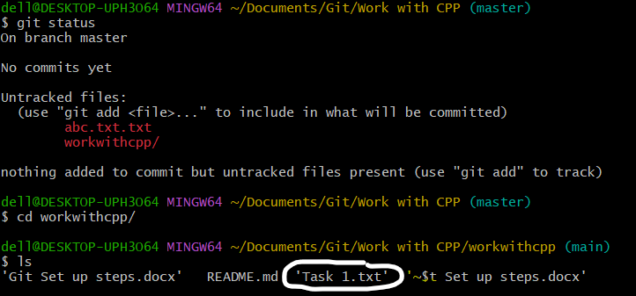
3. git add <file_name>
4. 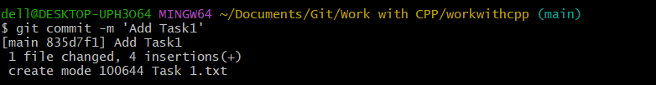
5. git commit
6. 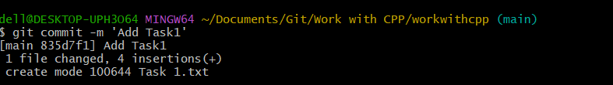
7. git push
8. 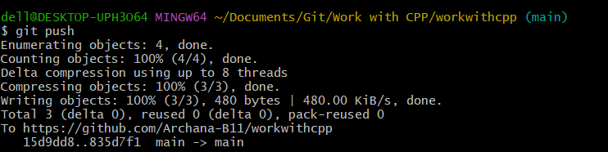

@Note:- In case, if it is ask for password then use ‘Sohan@2018@2013’